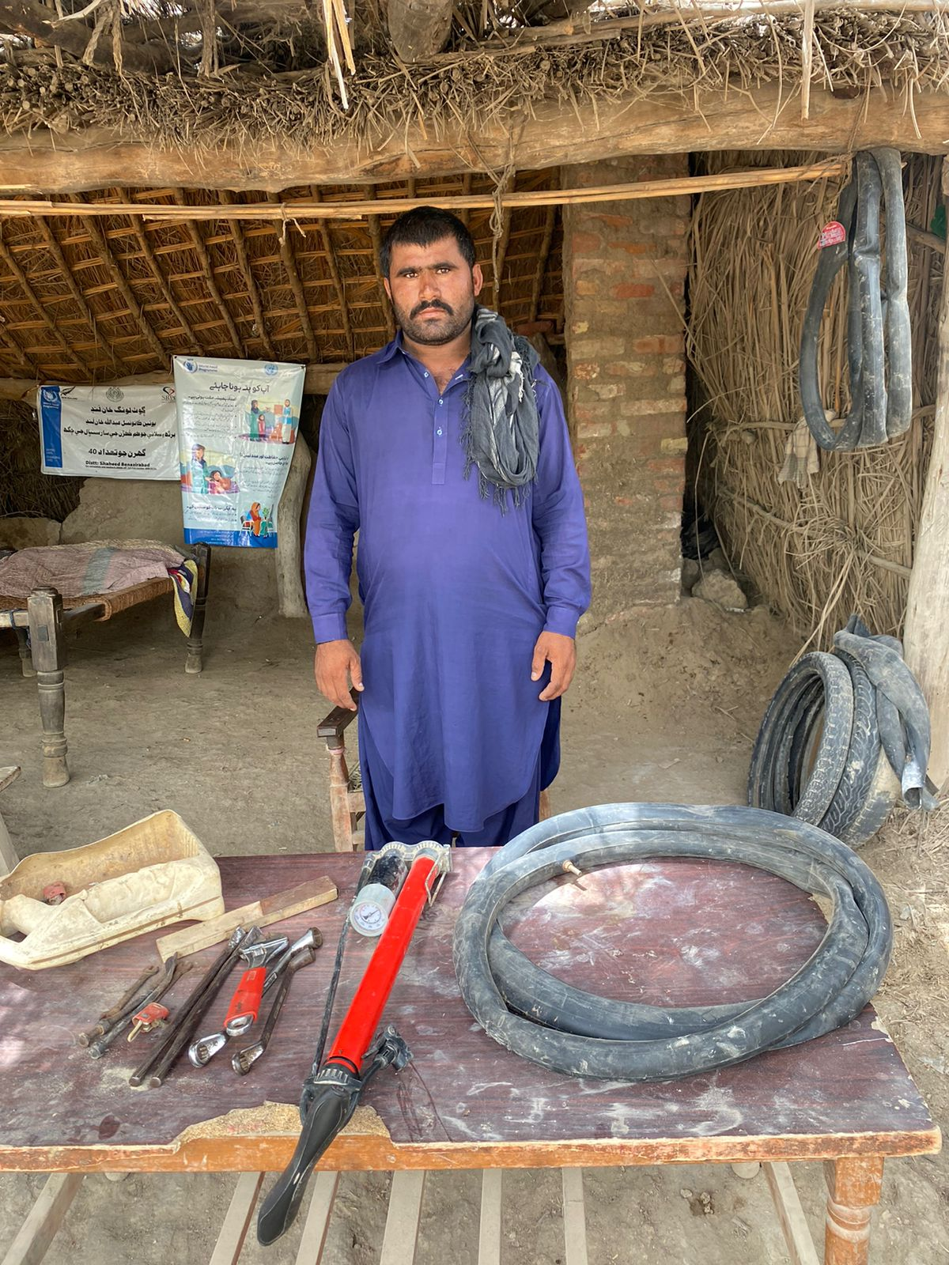
“Turning Challenges into Opportunities: Dolat Khan's Triumph”
WFP FFA Project
Sindh Case study
Dolat Khan, a resident of Village Lounge Khan Lund in UC Abdullah Khan Lund, was a labourer facing the responsibility of providing for his loving wife and five dependent children. His daily income, ranging from 300 to 500 PKR, was inconsistent due to the challenges of finding consistent work. Like many others, Dolat Khan had dreams of offering his family a better life, including quality education and nutritious food for his children. He tirelessly strived to turn these dreams into reality.
However, fate took an unfavourable turn in 2022 when heavy rains triggered devastating floods that destroyed the local fields and crops. This unexpected disaster left Dolat Khan without work, and his family found themselves in a state of uncertainty, having lost their belongings.
In the midst of this adversity, a glimmer of hope emerged through the "Food for Assets" Project, a collaborative effort between the World Food Programme (WFP) and the Sindh Rural Partners Organization (SRPO). Recognizing Dolat Khan's condition, he was selected to receive support from the project. Alongside receiving financial assistance totalling 24,000 PKR in two instalments to meet his family's immediate food needs, the project recognized that lasting transformation required more than just financial aid.
With this insight, the project initiated skills training sessions, empowering community members to acquire practical skills that could diversify their income sources and secure a brighter future.
Dolat Khan held this opportunity with enthusiasm, participating in the "Tyre Puncture Repairing" training provided by the project. Through dedication and hard work, he mastered the art of repairing punctured tyres. This training was not just about acquiring a trade; it was about gaining the tools to rebuild his life and ensure a better future for his family.
Outcome of the assistance, particularly the PKR 25,000 provided by ECHO:
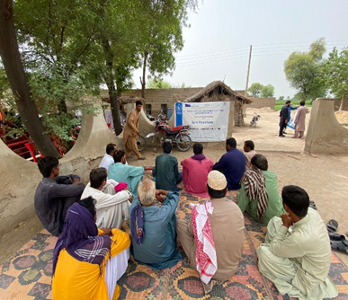
A pivotal moment arrived during the third cycle when Dolat Khan's family received an additional 25,000 PKR in support from ECHO Funding. Instead of solely addressing immediate needs, Dolat Khan made a forward-looking decision to invest in a brighter future. Leveraging his newfound skill in tyre puncture repair, he took a bold step and opened a tyre puncture shop in his village. This decision marked a turning point in his life, beyond his previous expectations—earning around 1000 to 1500 PKR daily.
Figure 1: A Tyre puncture repair training Session at UC Abdullah Khan Lund
As he looked upon his successful shop and witnessed his family's improved circumstances, Dolat Khan felt an overwhelming sense of gratitude.
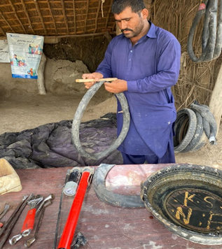
With his sustainable income from the tyre puncture shop, Dolat Khan's heart is full with hope and determination.
He aims not only to provide his children with a quality education and ensure his family has access to nutritious food but also to create a loving and nurturing environment where his family can thrive and flourish.
Dolat Khan's remarkable journey serves as a testament to the transformative power of empowerment and skill development. Through the collaborative efforts of WFP, ECHO and SRPO, he not only rebuilt his life but also became an inspirational figure within his community. His story underscores the profound impact that targeted support can have on individuals and their families, changing lives for the better and fostering resilience in the face of challenges.
Figure 2: Dolat Khan Working on his Shop

