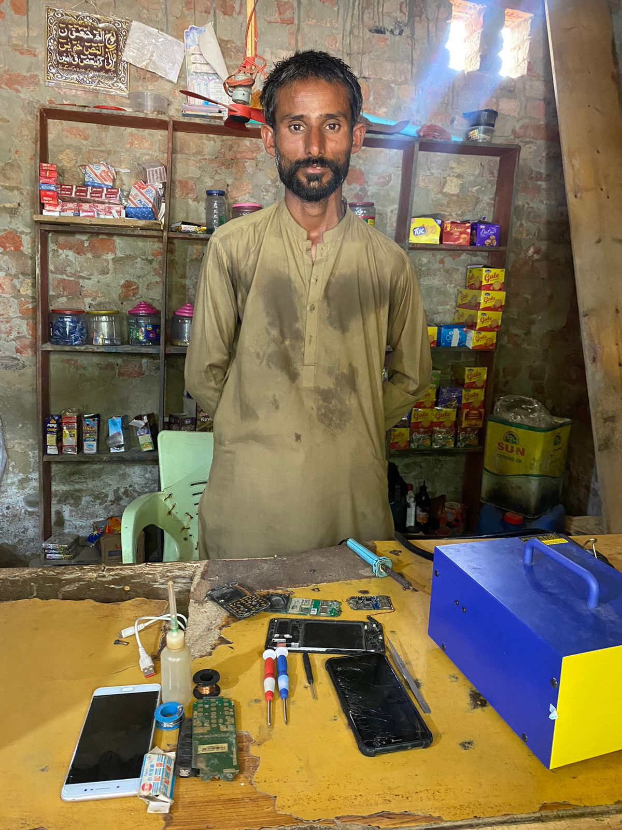
“Transforming Lives: A Story of Hope, Skill, and Support”
WFP FFA Project
Sindh Case study
Meet Fateh Muhammad is a labour worker who resides in Village Ghulam Hyder Rind in District Shaheed Benazirabad.. In the past, Fateh Muhammad used to work as a labourer in nearby fields, earning around 300 to 500 PKR per day. However, finding work consistently was a challenge for him.
Unfortunately, the situation worsened when heavy rains caused floods in 2022. The floods damaged all the fields, destroying the crops that were standing. This sudden disaster left Fateh Muhammad without any work, and he found himself without a source of income. This unemployment significantly affected his life, making it very difficult for his family. There were days when they struggled to have enough food to eat.
Then something good happened. An organization World Food Program (WFP) and Sindh Rural Partners Organization (SRPO) came to help families. They launched a project by the name of "Food for Assets" project, specifically designed to extend a helping hand to those affected by the floods. Their support extended to flood affected families. Moreover, guess what? Fateh Muhammad's family was among the fortunate beneficiaries, receiving support in two cycles, amounting to 24,000 PKR, which helped them, put food on the table during these challenging times. However, the impact did not stop at financial assistance but it recognized that a sustainable transformation required more than just monetary support. With this in mind, they initiated skills training sessions, empowering individuals in the community. Through these sessions, people were equipped with practical skills, offering them the opportunity to expand their income sources and secure a more promising future.
Fateh Muhammad has expressed interest in learning about Mobile Phone repairing due to its demand, potentially opening doors to better opportunities and higher wages. He actively participated in training sessions and acquiring skills in fixing Mobile Phones.

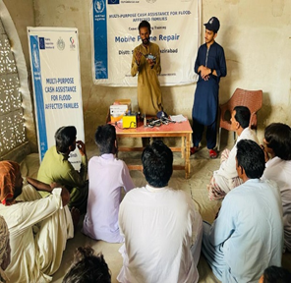
Outcome of the assistance, particularly the PKR 25,000 provided by ECHO:
Figure: Fateh Muhammad attending the Mobile Repairing Training Session Organized by WFP and SRPO
A key moment arrived during the third cycle when Fateh Muhammad's family received an additional 25,000 PKR by ECHO Funding in support. Instead of solely addressing immediate needs, Fateh Muhammad made a forward-looking decision to invest in a brighter future. He coupled his newfound skill in mobile repair and used this support to launch his own mobile repair shop. This strategic move reflected his recognition of the potential for long-term sustainability and financial independence through his innovative endeavour.
This decision transformed everything, previously, he struggled to find work and earn money, but now he could engage in skilled tasks for improved income.
With his new skills, Fateh Muhammad began earning around 1000 to 1500 PKR daily.
Now, Fateh Muhammad stands as a pillar of stability and support for his family, thanks to the collaborative assistance from WFP, ECHO, and SRPO. Through their support, he has established a sustainable source of income, realizing the dreams he once held for his children's bright future. His future plans are focused on providing his children with a better education and ensuring they have access to nutritious and wholesome food. Fateh Muhammad's journey is a testament to the transformative power of collective aid, determination, and the unwavering pursuit of a brighter tomorrow.

