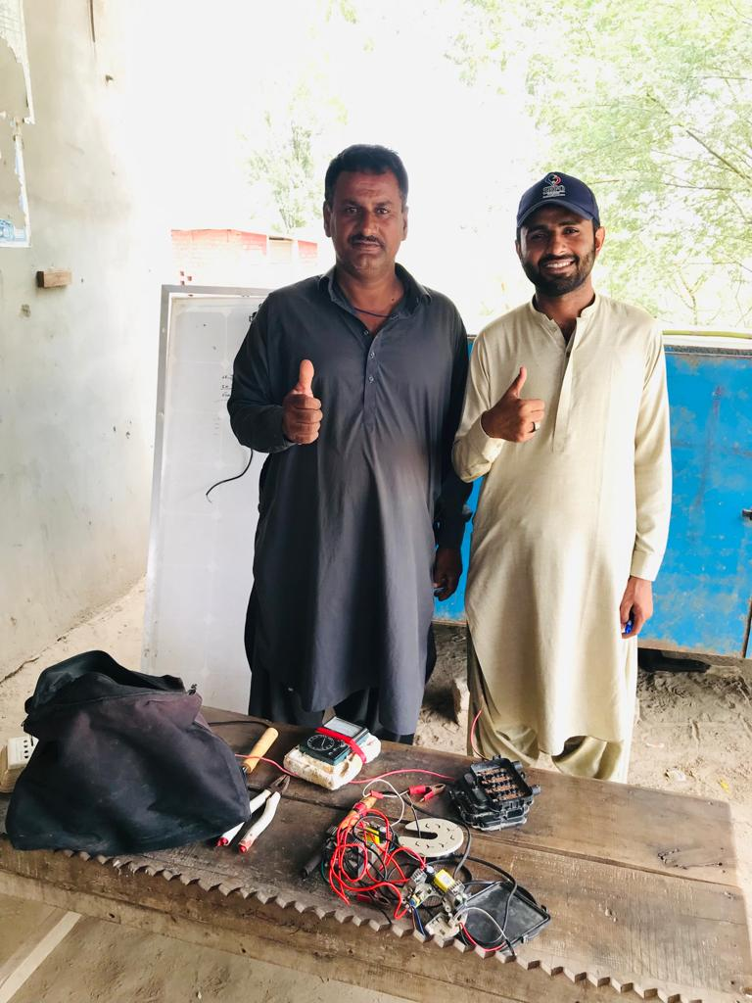
“From Flood Survivor to Skilled Entrepreneur”
WFP FFA Project
Sindh Case study
Abbas Ali, a labourer residing in Village Suleman Khoso in UC Abdullah Khan Lund, District Shaheed Benazirabad, faced the difficult task of providing for his wife and four children with an inconsistent income. His dreams revolved around a better life for his family, particularly ensuring quality education and nutritious food for his children.
The devastating 2022 Rain Flood struck their village, causing chaos, destroying homes, and leaving families in dire circumstances. Among those affected was Abbas Ali and his family. Their house submerged in floodwaters, forcing them to seek refuge on a nearby riverbank. The flood not only disrupted Abbas Ali's already unstable livelihood but also left them without shelter, food, and the means to meet their basic needs. They suffered weeks of uncertainty and hunger in the aftershock of the disaster.
Hope arrived in the form of the "Food for Assets" Project, a collaborative effort between the World Food Programme (WFP) and the Sindh Rural Partners Organization (SRPO). Abbas Ali's situation was assessed, and he was identified as a beneficiary of the project. Over two cycles, he received a total amount of 24,000 PKR in cash assistance. However, the project's impact extended beyond financial support.
Recognizing the importance of sustainable transformation, the project introduced skills training sessions aimed at empowering individuals to rebuild their lives with newfound expertise. Abbas Ali strategically choose the "Solar Panel Repair & Fitting Training" from a range of training options. He dedicated himself to the sessions, acquiring knowledge and practical skills in repairing and fitting solar panels. As the training concluded, Abbas Ali emerged not only with new skills but also with a renewed sense of purpose.
Outcome of the assistance, particularly the PKR 25,000 provided by ECHO:
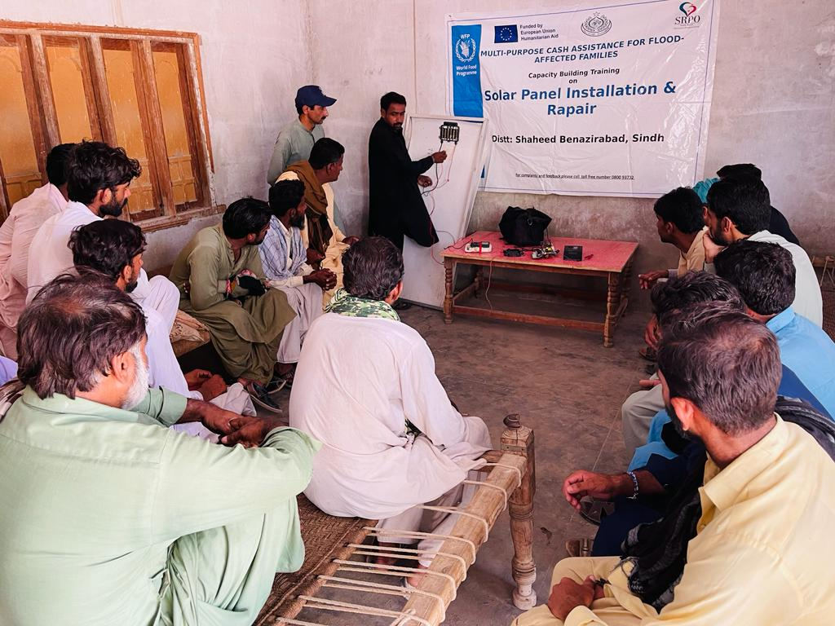
A turning point arrived during the third cycle when Abbas Ali received 25,000 PKR in support from ECHO Funding. Instead of merely addressing immediate needs, Abbas Ali made a forward-thinking decision to invest in a brighter future. Leveraging his newfound skill in Solar Panel Repair & Fitting, he boldly purchased materials for solar panel fitting and repair, initiating work within his village. Given the rising demand for solar energy due to electricity shortages and high costs, Abbas's work quickly gained traction, resulting in daily earnings of approximately 1000 to 1500 PKR.
Figure 1: A Solar Fitting & Repair session
Abbas Ali's newfound expertise instilled a sense of security and strength within him. Worries about his family's basic needs subsided, and with each successful repair, he bolstered his income and established a reputation as a dependable and skilled entrepreneur in his community.
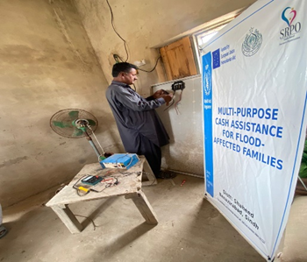
Looking to the future, Abbas Ali aims to further enhance his business and provide his family with a better standard of living, including quality education for his children and nutritious meals for his loved ones.
Abbas Ali's story exemplifies resilience and empowerment. Through the collaborative efforts of WFP, ECHO, and SRPO, he transitioned from a flood survivor facing an uncertain future to a skilled individual who not only rebuilt his life but also made a positive contribution to his community.
Figure 2: Abass Ali repairing solar plates at a villager's Home in his village

