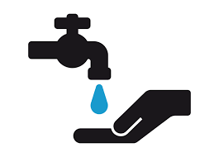

**PROFILE**

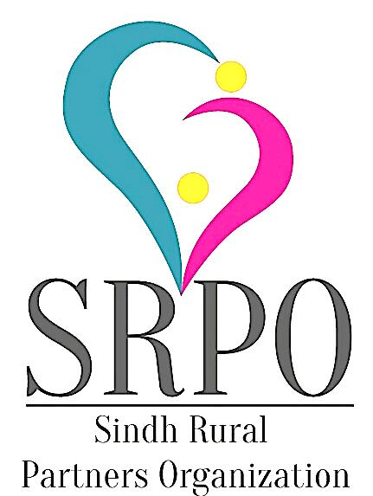

# Vision

Just, Gender Equitable, Agriculturally Rich,

Healthy, Educated and Prosperous Society

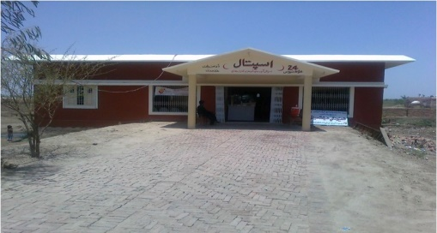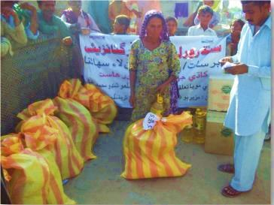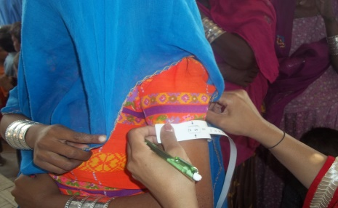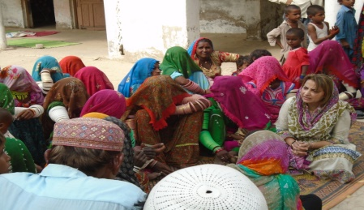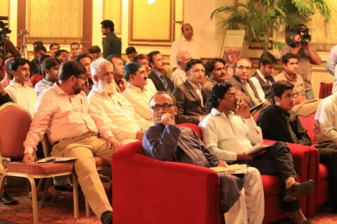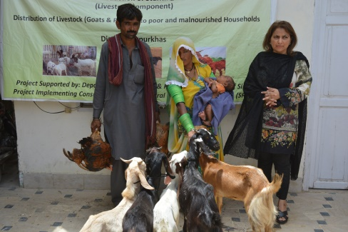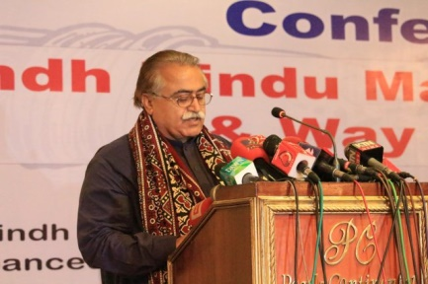

**CONTACT**

C-15, Block-18, Near Little Star School, Satellite Town, District Mirpurkhas, Sindh, Pakistan

Email: [srpo.hyd@gmail.com](mailto:srpo.hyd@gmail.com)

Tel: +92-233-862447

Web: www.srpo.org.pk

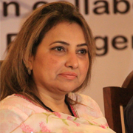**P R E A M B L E**

It is matter of great pride to share the foundation, on which SRPO exists and contributes in development of the society. Though it is self-explanatory, because SRPO is a women led organization. It was 1997 when women were not considered to be part of development process. There was very congested environment for women, and it was not an easy job to become change ambassador particularly in such discouraging society where women were considered to deal with domestic work only. Being a woman, I experienced such constraints that often kill potential and competencies of women. I dreamed that, there is need of person or institution to challenge such system and kick out the baseless and fake limitations. I was not only who cared about, there were few others in same boat, and we started discourses on women issues.

While endeavoring against such taboos, we felt there must be a formal platform to strengthen and empower women groups, after a series of sitting and serious discussions we decided to establish SRPO in 2001. I am lucky enough and thanked to struggling women partners for their trust, who hold me responsible to lead SRPO.

I feel immense pleasure to share that, SRPO objectively expand areas of operations and so far implemented 34 projects on food security, nutrition, agriculture, livelihood, WASH, health, education, Human & minority rights and emergencies in 00 districts of Sindh province. I tried my best to intact partnership and strong coordination with national, international and UN partners.

SRPO values communities and serve them with respect and dignity. I feel privileged to share progress that, SRPO has formed village based organizations, capacitate VBO members on different topics, ensured safe drinking water facility through installation of hand pumps, improved sanitation condition by constructing latrines in government schools, contributed in reducing stunting and malnutrition with distribution of goats, and poultry among deserving families, SRPO also provides primary health services through Community Health Center, increased literacy among adolescent girls, enhance skills of adult women and protect human rights particularly of minority communities, empowering women & youth, worked for reducing forced marriages and forced conversions. Also doing advocacy on various burning issues to create joyful and just society, more importantly SRPO became successes in passing Hindu Marriage Bills from Sindh Assembly.

In the last but not least, I must thank to BoD for continued support and valuable input in delivering best to deserving communities. On behalf of SRPO I pay gratitude to communities for due cooperation with SRPO at all level and accepting SRPO as their own initiative. Simultaneously, this entire achievement was not possible without sincere efforts of SRPO team and generous assistance of partners. SRPO is committed to provide best of the best services to the people living with discrimination in backward areas of Sindh.

**ZAHIDA DETHO**

**ABOUT ORGANIZATION**

### INTRODUCTION

Sindh Rural Partners Organization (SRPO) is a non-profit & non-governmental organization. SRPO is an initiative of development professionals and community activists who jointly formed SRPO in 2001. It is a registered entity under Pakistan Registration Law named “Voluntary Organization’s Ordinance XLVI 1961”.

It is Mutli-sectorial organization working on Environment, Climate Change, Education, Literacy, Women, Youth Empowerment, Research, Capacity Building, Health, Nutrition, Protection of Basic Human Rights, Disaster Risk Reduction, Emergency, Food Security, Sustainable Livelihood, Advocacy and Lobbying, with parallel focused on cross cutting themes including Gender Empowerment, Old age & Disable person, Advancing technologies, Social Entrepreneurship, and revive indigenous practices.

**VISION**

Just, Gender Equitable, Agriculturally Rich, Healthy, Educated and Prosperous Society

**MISSION**

Promoting, Expanding and Strengthen Social Organizational Base in Sindh Province to Alleviate Poverty, Develop Human Resource, Empower Women, Better Irrigation and Livestock Management, Educational Awareness, Ensuring Improved Healthcare Services, Gender Equity and Equality, and Promote Environment Friendly Agricultural Practices.

**IDENTITY**

“An initiative to meet the needs of communities”

**VALUES**

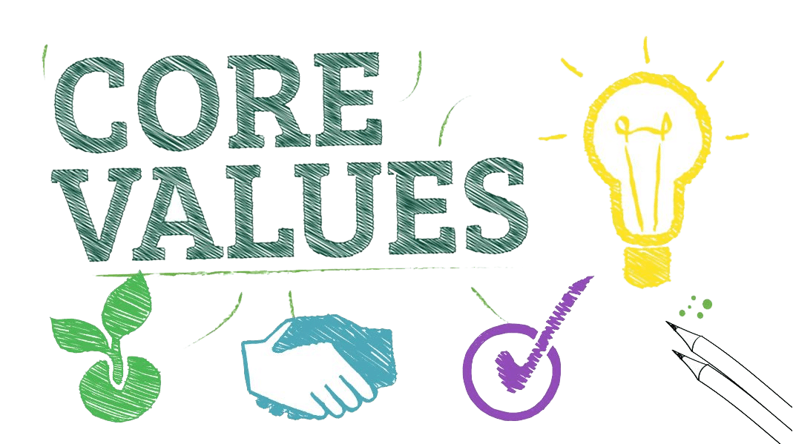

* Respect
* Integrity
* Communicating
* Excellence
* Environment
* Equality
* Transparency
* Answerable
* Partnership
* Research
* Mobilization
* Participation
* Advocacy
* Community Institutional Development
* Strengthen Partnership

**TARGET GROUP**

* Disable & old Age people
* Women & Children
* Disaster affected people
* Marginalized groups
* Ingenious communities
* Farmers
* Minorities

**SRPO’S APPROACHPOLICIES AND SYSTMES**

1. Ms. Zahida Detho Development Professional
2. Mr. Yousuf Memon Ex- Federal Secretary
3. Ms. Najma Lashari Social Activist
4. Ms. Sahib Khatoon Social Activist
5. Mr. Muneer Laghari Community Leader
6. Mr. Hazari Lal Minority Community Leader



* Human Resource
* Admin & Procurement
* Finance
* Anti-Harassment
* MEAL

**BOARD OF DIRECTORS**

**PROFESSIONAL TEAM**

**Zahida Detho – Executive Director**

Zahida Detho after completion of her master degree, started working in development sector. She earned extensive experience with one of the leading NGO of Pakistan. Where she achieved milestone and brought innovation in the field of community empowerment. She always stands against the violation of human rights and raised voice for gender equality. Currently she is serving as an Executive Director in SRPO and utilizing her qualification, expertise, experience and international exposure for the dynamic of the organization and empowering the communities.

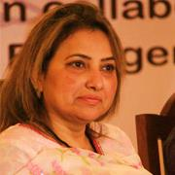

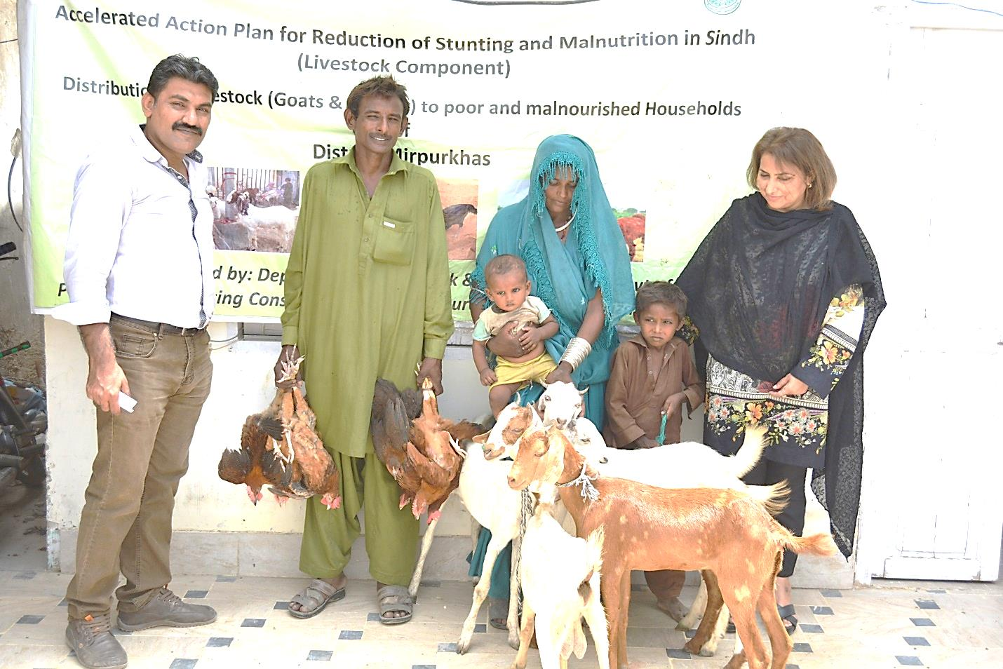**Kashif Mastoi – Program Manager**

Kashif has done masters in Commerce. He was affiliated with national and international organizations where he served on leading positions. Since last 00 years he is delivering his best with SRPO in capacity of Program Manager. He is responsible to provide technical and programmatic support to program team for producing excellence results and paying attention in resource mobilization.

**Yasir Kazi– Finance Manager**

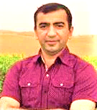

Yasir has done MBA specialization in Finance and he has working experience in finance with national and international organizations. Currently he is leading Finance Unit of SRPO and serving as Manager Finance. He can work very well on different Software of financial management, project and program budgeting, Audit and assist in administration and procurement.

**Noor Ahmed Narejo– MEAL Specialist**

Noor Ahmed did M.A English, during professional journey with reputable organizations he contributed in program Implementation, education, communication, monitoring and evaluation. At present, he leads SRPO’s MEAL Sector serving as MEAL Specialist. He is responsible for providing technical support to program and project teams. Conducts research, internal evaluations and facilitates external project and program evaluations. He ensures quality as per program outcomes and assist in program development as well.

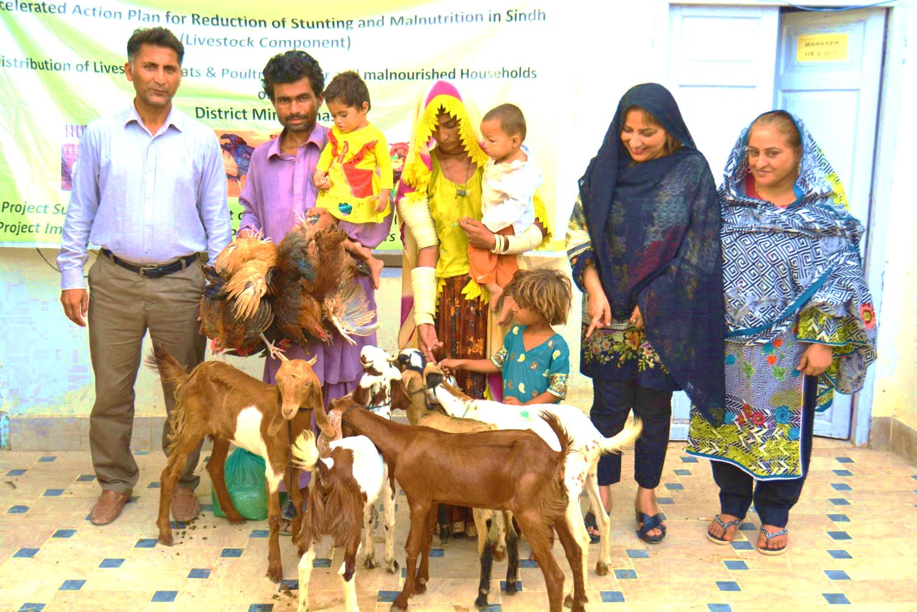

**AREAS OF EXPERTISE**

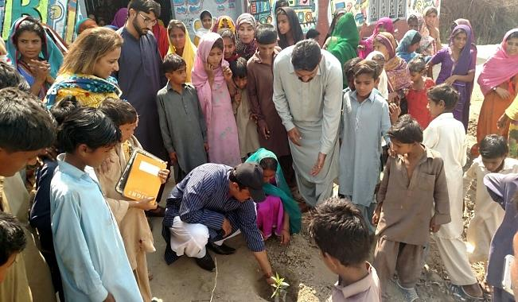**ENVIRONMENT & CLIMATE CHANGE**

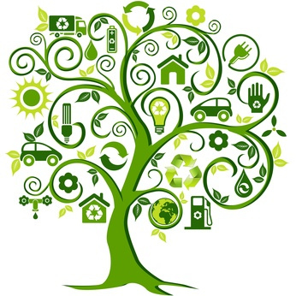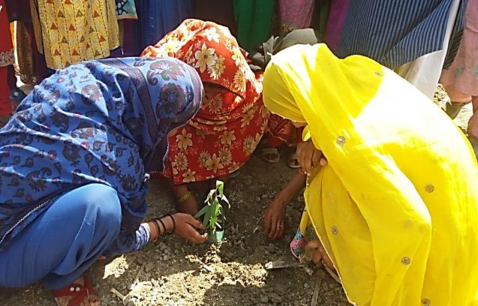

SRPO has developed strategy to capacitate the communities living in calamity hit areas of Sindh Province. SRPO designs programs with special consideration on environment and climate change. Since the journey, SRPO has been executing environment friendly projects that benefiting to communities living in operational area. Before designing and implementing projects SRPO considers that activities do not put environmentally negative impact on the lives of direct beneficiaries. SRPO’s communities are well oriented about the impact of environment and climate change. SRPO takes active part in the movement started for ensuring environment friendly atmosphere and raise awareness on climate change. SRPO imparted various training covering Environment, Climate change and its impact on livelihood and daily life the communities.

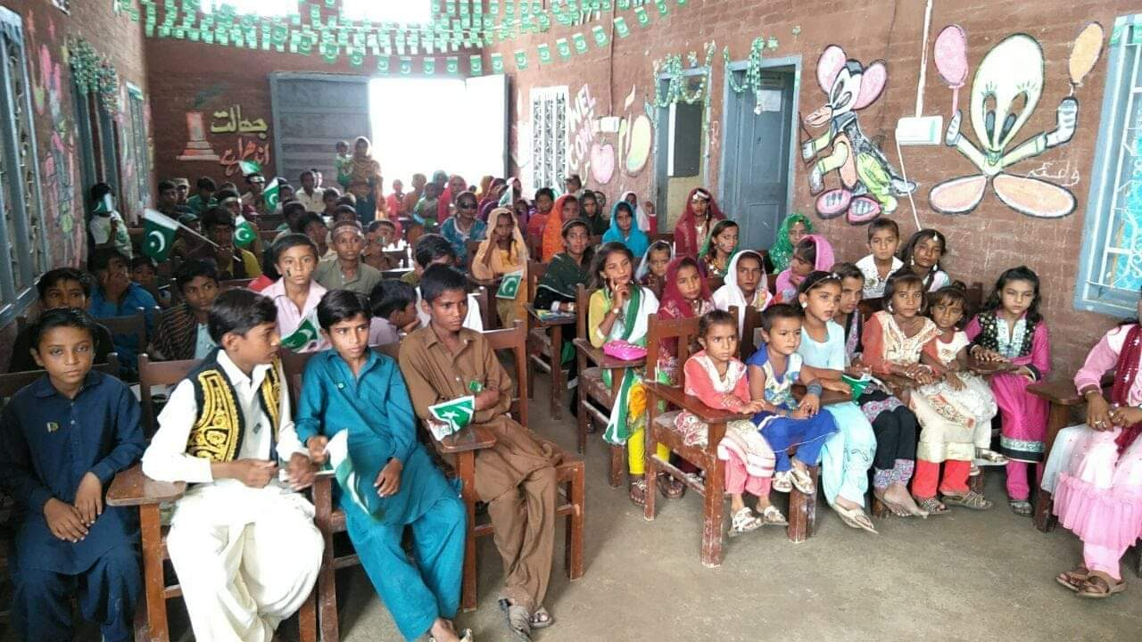**EDUCATION & LITERACY**

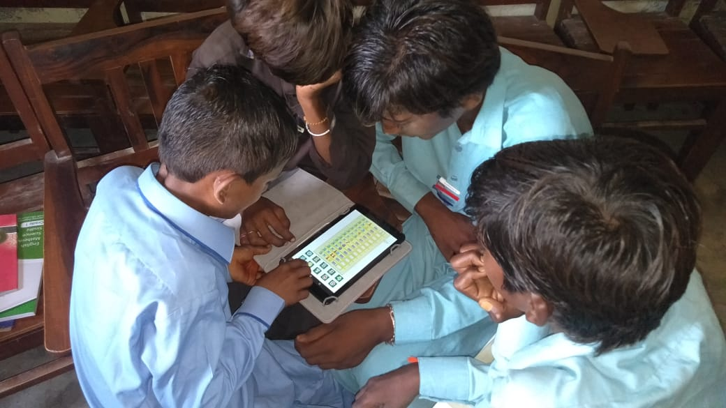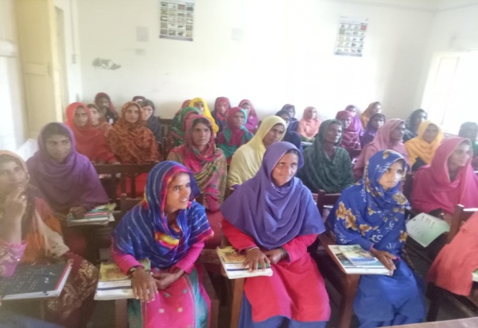

SRPO aims to contribute in improving quality of education in rural and semi-urban areas of Sindh. SRPO’s strategy to work for Education & Literacy is to raise awareness and establish formal and non-formal educational institutes. SRPO adopts participatory approach and keep on board to all key stakeholders including teachers, SMC members, Teachers associations, District and Provincial Education departments, VBOs and parents for taking part to improve and deliver quality education and increase literacy ratio in rural areas of the Sindh. SRPO organizes extra curriculum activities in government schools, as well as in those schools run under public and private partnership to explore hidden talent. SRPO mobilizes resources and invites educationist, development partners and philanthropists for assessing the basic facilities in schools and join hands to ensure availability of missing facilities. SRPO also do lobbying with district administration to allocate sufficient budget for schools. SRPO campaigns to increase enrollment and reduce drop out ratio in Government Schools.

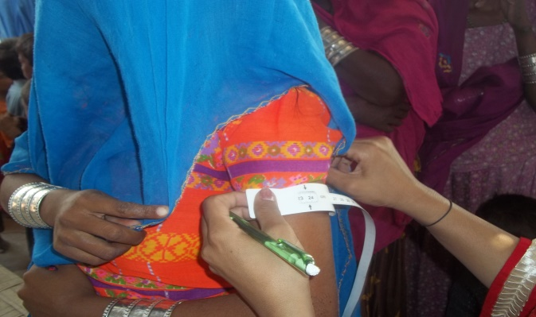**HEALTH & NUTRITION**

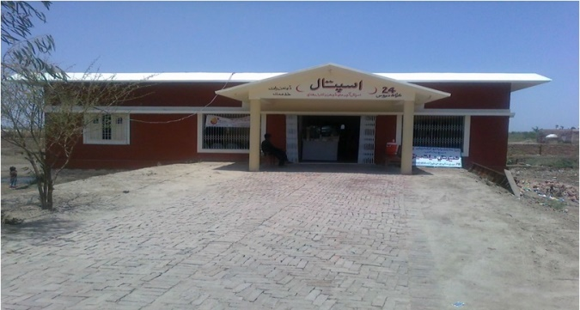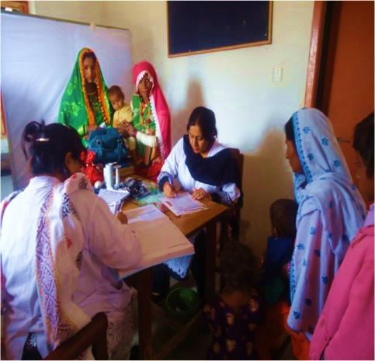

SRPO adopts a holistic approach to women’s health which includes both nutrition and health services and special attention to the needs of women and the girls at all stages of the life cycle. SRPO established a Community Health Center (CHC) at 78-Mori Bus Stop on Mirpurkhas-Umerkot Road in collaboration with Trust for Voluntary Organization (TVO). After completion of project life, CHC became sustained and now provides OPD, Antenatal, Postnatal and Delivery services to a population of 42,000 of Union Council Balochabad and Jhulori. SRPO is providing Ambulance service to the serious patients of the area. A six rooms building including a Training Hall for the communities in the field of health and education have been constructed at the site.

SRPO has joined hands with Government of Sindh to execute AAP-L project as a Project Implementation Consultant. SRPO plays its role in identification of most deserving beneficiaries for receiving package of Goats and Poultry birds to avail pure nutrient food such as Milk, Yogurt and Egg. SRPO establishes Village Based Organizations for ensuring project’s sustainability. Capacity building of livestock dependent families is also one of the key components of this project, in this regard SRPO conduct “Training Need Assessment” to identify most relevant beneficiaries for participating in capacity building events.

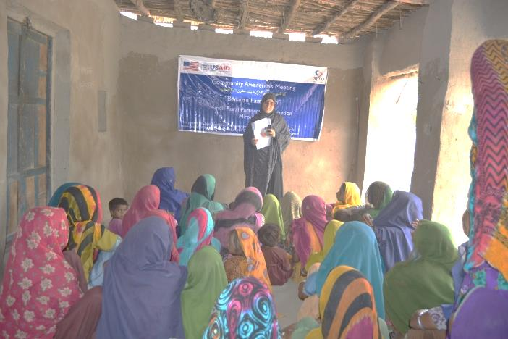**WOMEN & YOUTH EMPOWERMENT**



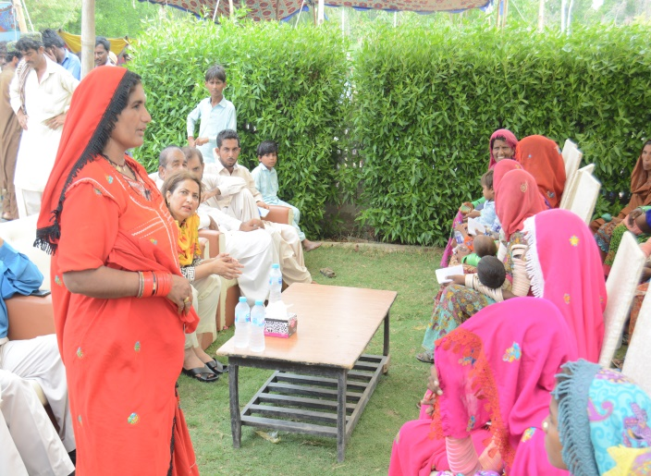

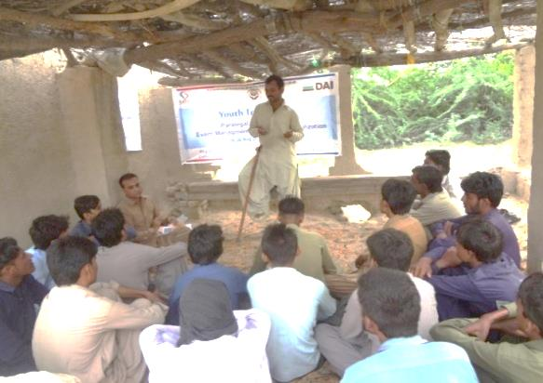

SRPOhas been engaged in rendering servicesfor women & youth empowerment. Since its establishment, SRPO successfully implemented various projects focusing on capacity building of youth and their role in peace, harmony and participating in policy development process for holistic development of society. SRPO realizes that without investing on women emancipation “Sustainable Development Goal” cannot be achieved. Hence, organization works for increasing literacy and enhancing skills of women to contribute for sustainable development and take part in decision making for vibrant society.

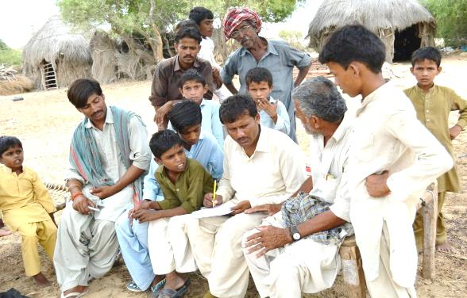**RESEARCH & CAPACITY BUILDING**



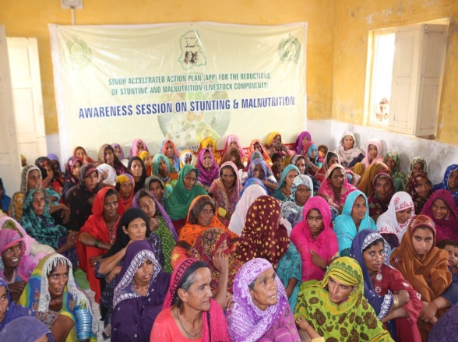

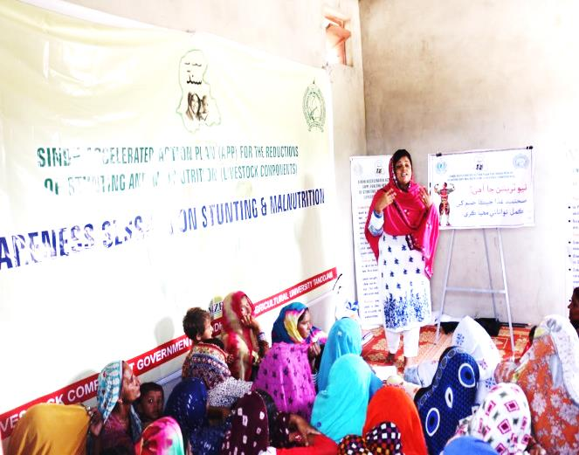

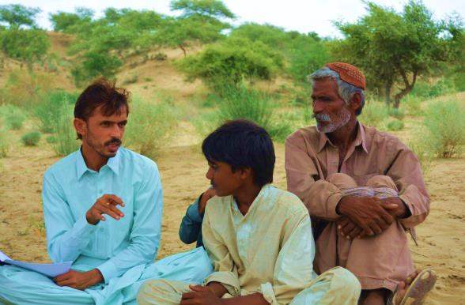

Itis backbone of the organization. SRPO’s name is listed among very progressive Civil Society Organizations of the province. SRPO strongly believes that research is the key to provide scientific and strategic approaches and way forward for long-lasting and sustainable intervention. SRPO has extensive experience in the field of research, SRPO credited in conducting research on Forced marriage, forced Conversions, youth, Peace & harmony, Education status, Drought and nutrition. In light of research findings SRPO designed training manuals, built capacity of staff, communities, youth and other stakeholders including lawyer/advocates, media and Government line departments.

**WATER AND SANITATION, HYGIENE**

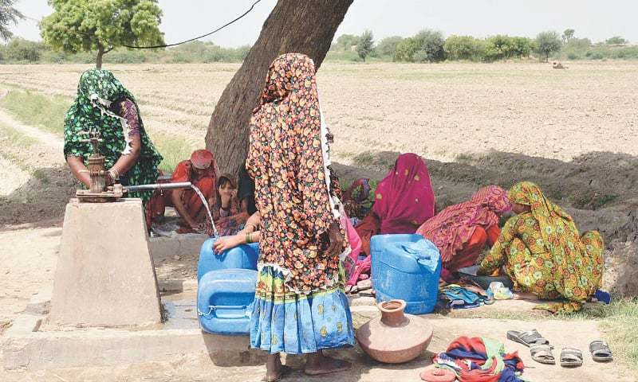





SRPO takes efforts to improve hygiene status in operational areas. SRPO organizes sessions among male, female and students to raise hygiene knowledge on different topic such as “Personal”, “Environment” and “Domestic Hygiene”. SRPO introduced “Hygiene Kits” in SEF supported schools administratively run by SRPO, where learners were oriented to use Hygiene Kits for ensuring personal hygiene at schools and home. SRPO celebrates international days to spread WASH knowledge and also participates in coordination meetings being arranged by WASH stakeholders, PHED and local Government of Sindh.

SRPO worked with UNICEF under Water, Environment and Sanitation (WES) Project in district Mirpurkhas. In which SRPO installed 60 Hand Pumps in the rural areas for providing clean drinking water to communities. Also constructed and repaired 30 latrines of Primary Schools of Taluka Samaro. SRPO provided training to the School Teachers, Women, Masons and Activists regarding hygiene education, sanitation, use of Hand Pumps and Environment. SRPO realizes open defecation is increasing day by day, which caused unhygienic and unhealthy environment. Hence, SRPO integrated WASH activities in regular projects where communities were sensitized to not defecate in open areas, SRPO field teams discussed with communities about risk associated with Open defecation.

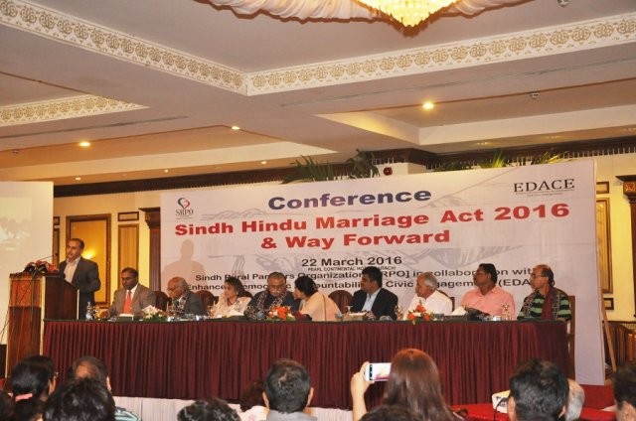**ADVOCACY & LOBBYING**

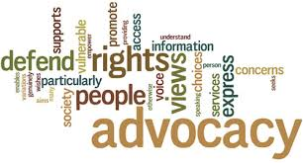

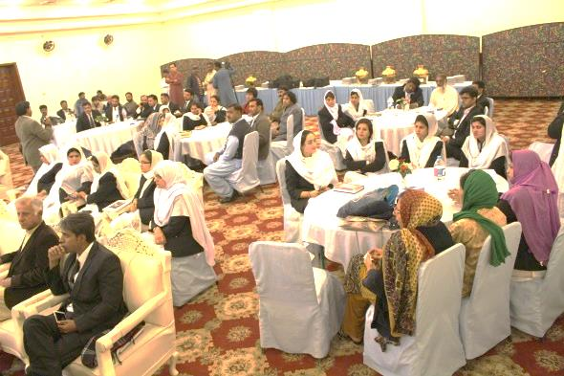



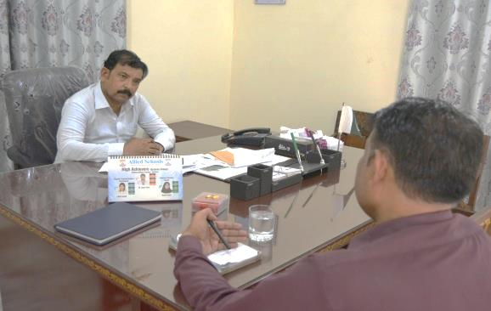

SRPO has been engaged in advocacy and lobbying with legislators, implementing institutions, government departments and civil society to bring social change in the society. SRPO works for positive and necessary change in policies and laws which benefits to powerless. SRPO brought positive changes through successful advocacy and lobbying campaigns. SRPO experienced that Advocacy and Lobbying is important to bring likeminded on one page for influencing the authorities to make well planned and timely decisions that protect rights of the common citizens and serve them on equal basis. SRPO designs well strategic advocacy campaigns, which attracted change makers for becoming part of its struggle. SRPO is a source of echoing the voice of marginalized and powerless communities in very effective manners that knocked the door of authorities for developing policies to empower poor communities at all level.

**FOOD SECURITY & LIVELIHOOD**



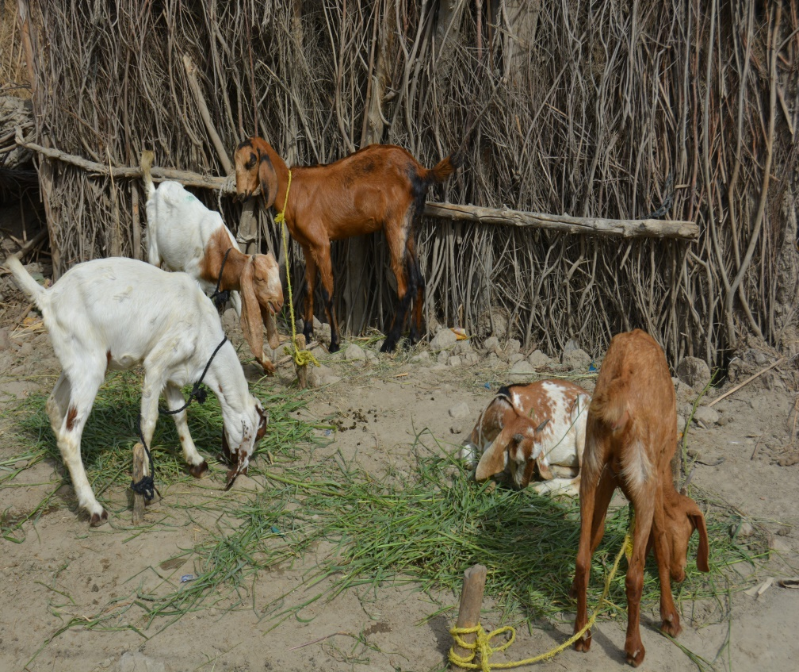



Sustainable income sources are high need of the time. SRPO encourages people for entrepreneurship and assets building aiming to decrease the vulnerability in targeted areas. SRPO strengthens linkages of community with market and explore new ways in agriculture growth, because majority of the rural population depend on livestock rearing and agriculture as their prime livelihood source. SRPO intervened for assets building and provided productive assets that economically empowered poorest of the poor households. SRPO focused to work in drought and other disaster hit areas who face food insecurity due to dearth of income generation opportunities. SRPO helped food insecure families for having source of income to ease their families.

**PROTECTING BASIC HUMAN RIGHTS**



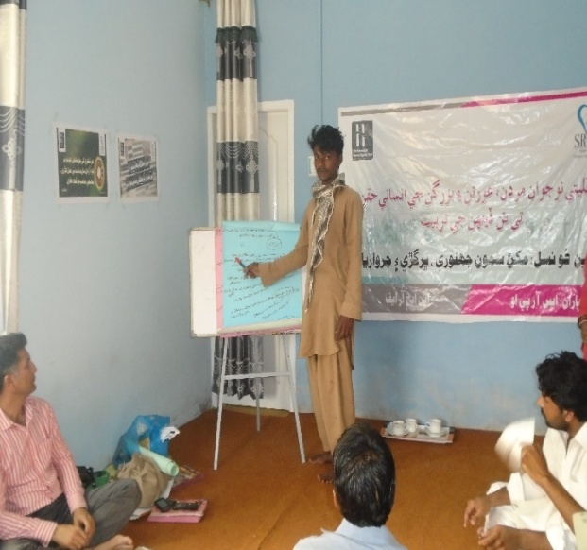



SRPO envisioned for peaceful society, and advocates for equal rights of all citizens, where everyone entertains human rights and live in joyful and just society. SRPO launched campaigns for protecting human rights in different districts of the Sindh province. SRPO doesn’t tolerate injustice, discrimination and violation of human rights at all. SRPO always remains in resisting position against extremism, forced conversion, child abusing and honor killing. SRPO campaigned for minority rights in. As fruit of long struggle and tireless efforts SRPO become successful to mobilize and sensitize the legislators to unanimously pass “Hindu Marriage Bill” in Sindh Assembly. Currently SRPO is lobbying with respective departments to place working mechanism for effective implementation of Hindu Marriage Bill.

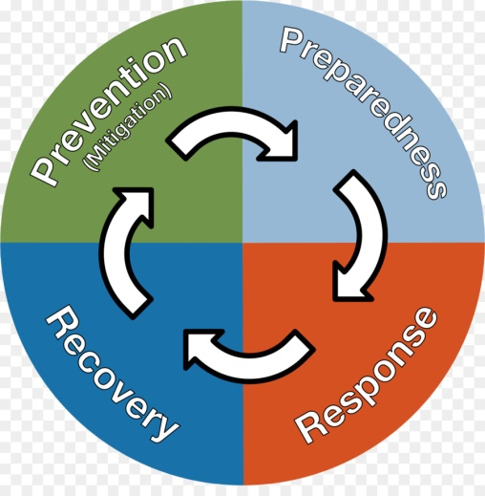**DRR & EMERGENCY RESPONSE**

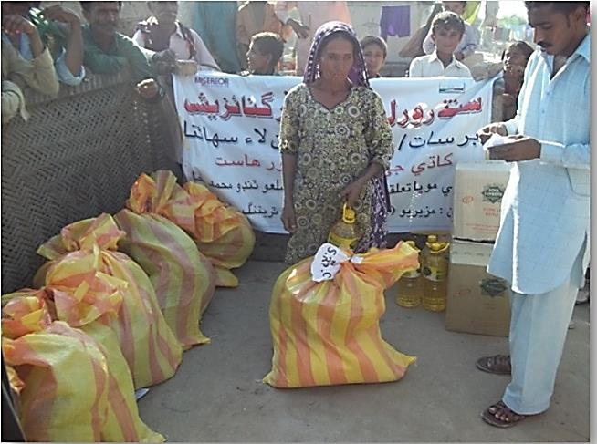

Sindh province experienced disasters in different years. Hitherto, time to time it is predicted by Pakistan Meteorological department that various districts of Sindh would face calamities, such as Heavy Rain caused flood/Disaster, as well as low or insufficient rain caused drought situation and water shortage. It needs special consideration to reduce vulnerability and risk occurs due to such calamities. SRPO conducts assessments to response in emergencies and support to affected population in distributing Food Packages, NFI Kits, constructing shelters, building capacity, establishing temporary learning centers, restoring livelihood sources and rehabilitate infrastructure and among affected families. SRPO always remains in front line to advocate for developing plans to meet the emergencies and give input in developing district level DRR plans and policies.

**CROSS CUTTING THEME**

* Gender Empowerment
* Old age & Disable person
* Advancing technologies
* Social Entrepreneurship
* Revive Indigenous practices

**ACHIEVEMENT/NETWORKING/REGISTRATION**

* PASS Hindu Marriage Bill
* Member Pakistan Peace Coalition (PPC)
* Member Child Protection Unit (Mirpurkhas)
* Member Social Welfare Council at Provincial level
* Member National Humanitarian Network(NHN) Pakistan
* Member Land Reform Movement (LRM)
* Member Disaster Committee(Mirpurkhas)
* Member District POLIO Eradication Committee
* Member District MNCH Committee
* Member District Anti-GBV Committee
* Member of Peace & Justice Network Pakistan
* Member of Indus for All
* Member of Rotary International- Pakistan
* Members of Provincial Human Rights Defender Forum
* Member of Sindh Civil Society Disaster Management Consortium
* Member of Sindh Disaster Management Forum
* Member of Pakistan Civil Society Forum

**CONTRIBUTION IN DEVELOPMENT**

|  |  |  |  |  |
| --- | --- | --- | --- | --- |
| S. NO | PROJECT TITLE | YEAR | FUNDING SOURCE | LOCATION |
| 1 | Accelerated Action Plan Livestock component | 2018-2021 | Govt. of Sindh | 24 Districts of Sindh |
| 2 | AALTP | 2017-2019 | SEF | Mirpurkhas |
| 3 | Youth Empowerment for Peace Building | 2017 | DAI (Azm-e-Pakistan) | Karachi |
| 4 | Strengthening District Bar Association & Establishing Facilitation Kiosk at Court | 2017 | GEP-USAID | Hyderabad |
| 5 | Because I am a Girl | 2016 | SGAFP-USAID | Mirpurkhas |
| 6 | Enhance Reading Skill of Primary level & Promote Girls Education | 2016 | PRP-USAID | Tando Allahyar |
| 7 | Promoting & Protecting Minority Rights in Southern Sindh | 2015-2016 | DAI-EDACE | Mirpurkhas, Umerkot and Tharparker |
| 8 | A Living from Livestock | 2014-2015 | Govt. of Sindh | Mirpurkhas |
| 9 | Stopping Force Marriages and Force Conversions of Hindu Girls at | 2014-2015 | NHRF | Mirpurkhas |
| 10 | Community Awareness Raising Of Polio | 2013-2014 | Rotary International | Mirpurkhas |
| 11 | Baseline Study on Force Marriages and Force Conversions of Hindu Girls | 2013-2014 | NHRF | Mirpurkhas |
| 12 | Family Health Center | 2011-2012 | NATPOW | Mirpurkhas |
| 13 | SMC Mobilization/ Revitalization and Capacity Building | 2011 -2012 | World Bank, European Union, Govt: of Sind through Secon Consultancy | Tando Mohammed Khan, Badin |
| 14 | Livelihood Restoration and School Rehabilitation | 2011-2012 | TDH | Jamshoro |
| 15 | Community Based Management of Acute Malnutrition | 2011-2012 | UNICEF | Mirpurkhas |
| 16 | Mother & Child Health Center | 2011-2012 | CARE | Mirpurkhas |
| 17 | Emergency Response Flood | 2011 | TDH | Mirpurkhas |
| 18 | Emergency Response Flood | 2011 | Miserior (Germany) | Tando Mohammed Khan |
| 19 | Emergency Response Flood | 2010-2011 | DTCE | Mirpurkhas |
| 20 | Capacity Building of CCBs | 2007 | DTCE | Mirpurkhas |
| 21 | Adult Women Literacy | 2006 | SRPO & Rotary Club | Mirpurkhas, Umerkot and Tharparker |
| 22 | Rural micro-credit program | 2002-2005 | OCT | Mirpurkhas |
| 23 | Adult Women Literacy project | 2006 | NCHD | Mirpurkhas |
| 24 | Education | 2003-2005 | NCHD | Khairpur |
| 25 | TBA Training & Health Awareness | 2003-2004 | CIDA | Mirpurkhas |
| 26 | Adult Women Literacy and Income Generation | 2003-2004 | CIDA | Mirpurkhas |
| 27 | Water, Environment and Sanitation | 2002-2004 | WWF-Pakistan | Mirpurkhas |
| 28 | Income generation of farmers through IPM and EM-Technology | 2004 | WWF-Pakistan | Mirpurkhas |
| 29 | Natural Resource Management | 2002-2004 | Self-funded | Mirpurkhas |
| 30 | Labor Councilors/Activists Education | 2002-2004 | PILER | Mirpurkhas |
| 31 | Water, Environment and Sanitation (WES) Project: | 2002-2004 | UNICEF | Mirpurkhas  Umarkot |
| 32 | Community Health Center | 2003 | TVO | Mirpurkhas |
| 33 | Polio Awareness Raising | 2003 | UNICEF | Mirpurkhas |
| 34 | FO Formation | 2002-2003 | SIDA | Mirpurkhas |
| 35 | Social Mobilization program in rural areas | 2002 | Self-Funded | Mirpurkhas |
| 36 | Human Resource Development | 2002 | Self-Funded | Mirpurkhas |
| 37 | Voter Education Campaign | 2002 | UNDP/ Election Commission of Pakistan | Mirpurkhas |
| 38 | Farmers’ Income Generation | 2002 | CIDA | Mirpurkhas |

**ORGANOGRAM**

Board of Directors

Executive Director

Manager Program

Audit Committee

MEAL

Administration

Finance Officer

Human Resource

Project Manager

MEAL Officer

Admin Officer

HR Officer

Finance

Program Development

Sectorial Managers

PD Officer

Field Staff

CONTRIBUTING FOR UPLIFTING THE MARGINALIZED COMMUNITIES

**OPERATIONAL AREA**

**PARTNERS**

