In Mirpurkhas district, where the rains brought destruction in its powerful way, union council Sherl came across as the most affected area of ​​Mirpurkhas district, where crops and animals were destroyed along with the loss of houses. The resources were destroyed and the houses were destroyed. There, along with the good people, NGOs and government aid, SRPO –WFP also started a complete assessment at the UC Sherl, in which the damages of the victims were estimated. During the assessment, very painful statistics were come up and people got a chance to see their lives up close. Some victims are very disappointed and some have hope to live again. Among them, one of the men, Mr. Esso, S/O of Pukho village, Khadim Nukhraj, was among the victims. His house was badly damaged and he was jobless too. He got 12000 amount from SRPO-WFP . He started a vegetable cart from this amount. He is very thankfull to SRPO-WFP.He further said ALHUMDULILLAH now I am independent and can earn Halal Rozi.
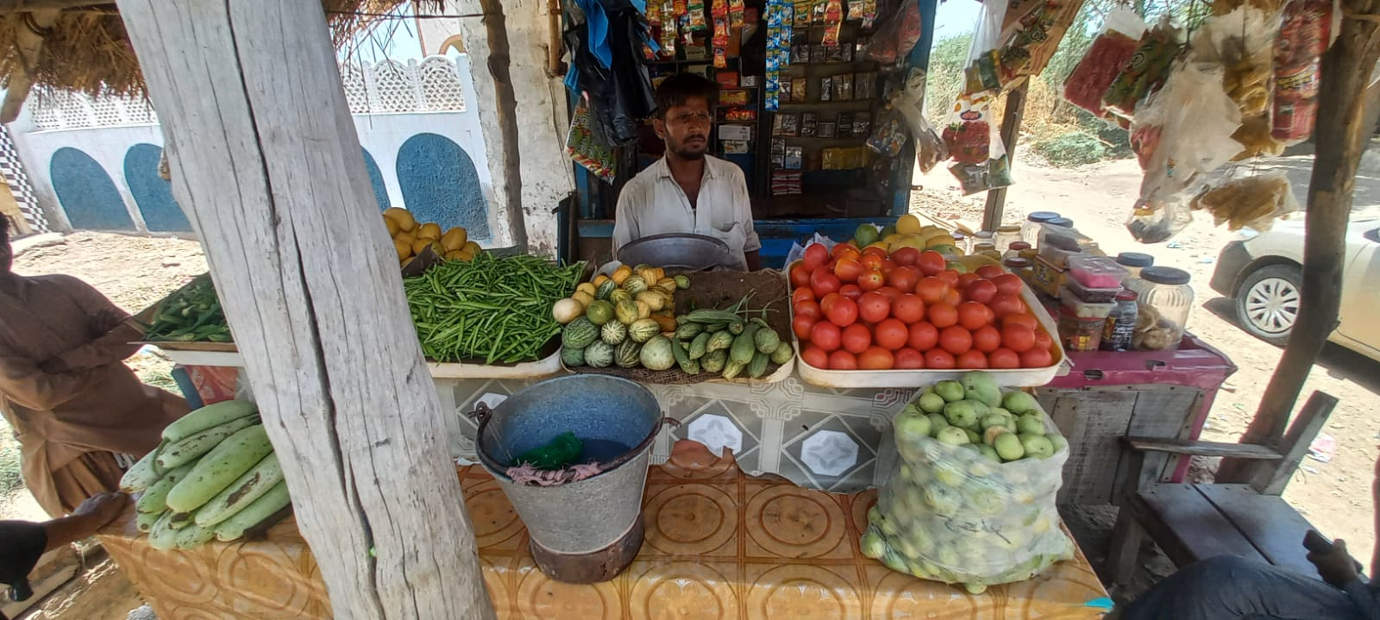
NAME: ESSO
CNIC:44202-67896137
CONTACT:03463628021

