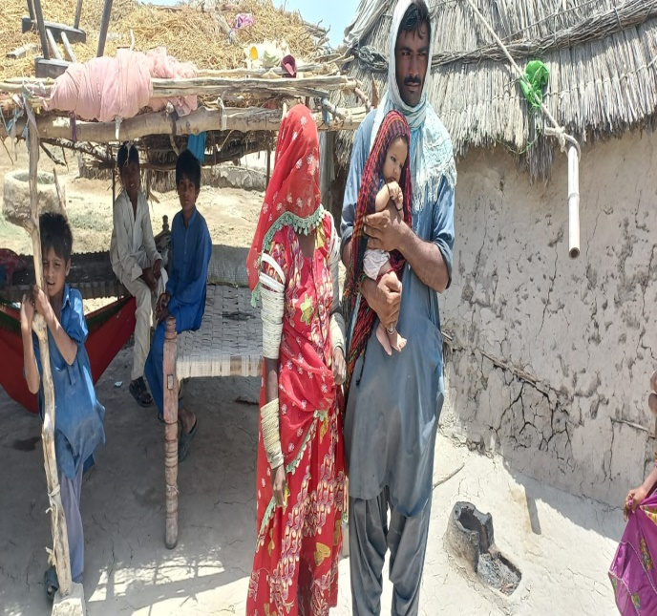
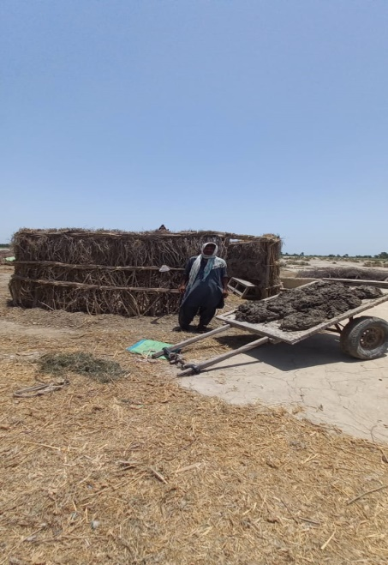
The rains of 2022 where the harvest disturbed the houses and residences of many, there also caused a lot of damage to the employment of the people. The victims used the money they had for food. Due to poverty, this money could not be used for food for many days, so the problems continued to increase. In main markeet, due to shortage of money, shops started to close down, SRPO team immediately started a survey with the help of WFP, where there was a lot of damage and food shortage were seen. The relief that was being given at that time was one or two meals a day by the philanthropists and there was a quality of uncertainty among the victims. During the survey, Mr. Chutton, whose village Khadim Nukhraj, was also included in the survey. As soon as he received the money through easy paisa, he saved 12,000 rupees for his wife delivery and he also saved money for making his new hut. Chutton is very happy with this amout as he said me and my wife are very thankfull to WFP- SRPO as now I have a house and my a healthy child.
NAME:CHUTTON S/O PUNIO
CNIC:4420279352049
CONTACT:03443720336

