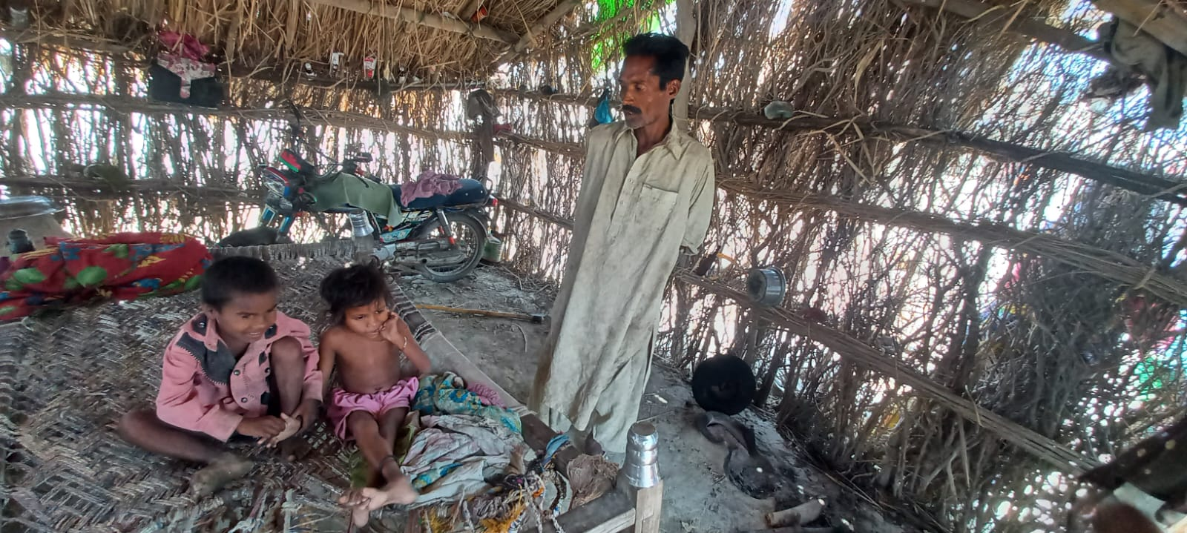
A vulnerable benefaciry named Partab belongs to district Mirpurkhas village Kewro Nukhrej which is suitated in UC Sheral.In last year flood his wife died after a long chronic illness. He have two childs who are disable. Partab is a jobless person and he haven’t enough money for his childs treatment and grocessary. After receiving cash from SRPO-WFP which was 12000 . He purchased medicines for his childrens and he also purchased some ration from the left over amount. His children were very happy because they have food and medicines due to this amount. They are very thank ful to SRPO –WFP . Partab said we are just surviving due to NGO Which are working in our area.
NAME: PARTAB S/O ARJAN
CNIC:4410387985395
Contact:03443146614

