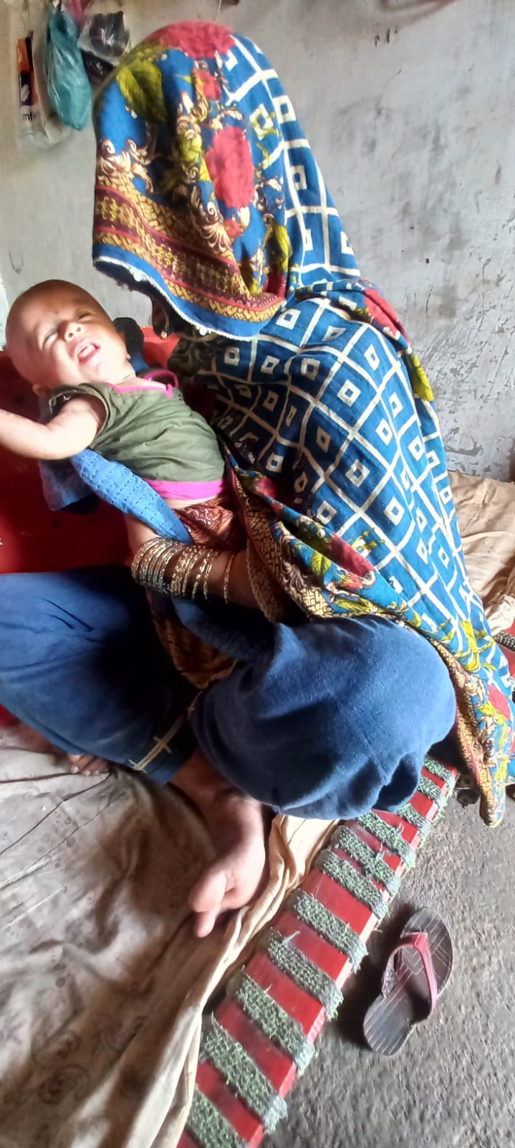
NIDA belongs to district Mirpurkhas village Khadim Nukhrej which is situated in UC Sherl. Nida was pregnant and near to deliver her child in critical conditions of rainy seasons . During assessment phase team ensured her that you will get amount . She got a loan from the landlord for her delivery case. After receiving 12000 she returned that loan to the landlord and from remaining 2000 she purchase clothes for her child. Nida is very thankful to SRPO-WFP as said”You are angels you helped me in my critical time.”
NAME :Nida W/O Naveed ALI
CNIC:42501-5747985-2

