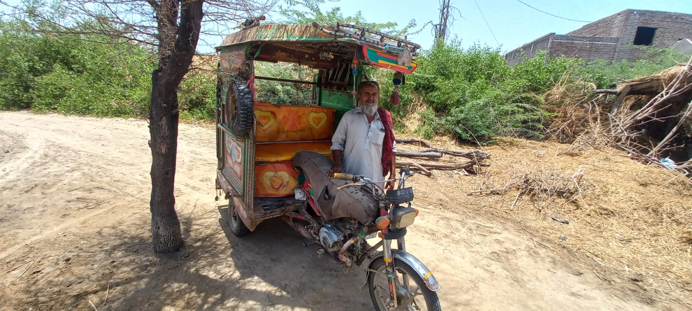
A beneficiary named Daim Ali from District Mirpurkhas village Khadim Nukhraj which is situated in UC Sherl. In last year rain he sold his animals and migrated . In rains his riksaw have some engine issues. SO, he didn’t utilize this for bread winning . when he got 12000 from SRPO-WFP he invest this amount on Rikshaw and start earning from this. He is only one bread winner in his home. He was very happy he said no body gives me loan for this .I am very thank full to SRPO-WFP because this amount is a life turning point for me.
NAME: DAIM ALI/OBHAYO
CNIC:4130625600649
CONTACT:03438036759

