SRPO Jacobabad Success Story
CBT Program by World Food Program (WFP) - 2023

Village Attur Bhanger
UC Ahmed Pur

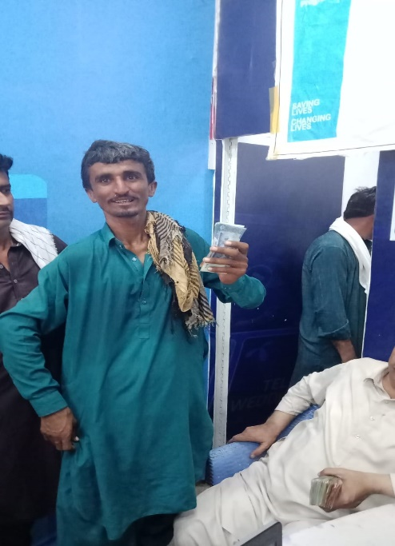
Abdul Razzaq
CNIC: 4310248030445
Mobile: +923479937414

“I have no source of income and cannot work as regular labor due to disability that I have a Paralyzed Arm. I am Thankful to SRPO and WFP that their field team in Jacobabad visited my village and considered me as per their criteria and given me the token (for cash assistance) so that I could utilize the amount for Food and Medicine, I am married and I have 02 children and they are too young to work and bear the household expenses and I am really thankful to SRPO and WFP field teams that they helped me out in such situation. I you ask me honestly; I can’t believe this”
Abdul Razzaq
(Jacobabad Flood Affected and Beneficiary of CBT- SRPO/WFP)

