SRPO Jacobabad Success Stories for the Year 2023
CBT Program by World Food Program (WFP)

Village Muhammad Nawaz Bahrani UC Ahmed Pur
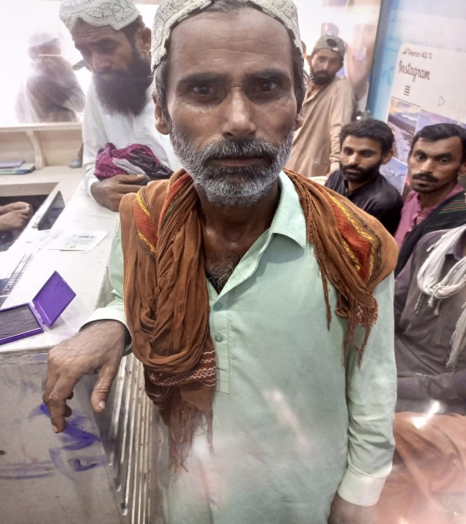
Muhammad Chuttal S/O
CNIC Num : 4310246032227 Date Of Birth : Mob Num : 03053845620
As per me I have no source of income and I have a disability that I don’t have an eyesight and I am Blind by birth and SRPO Jacobabad team visited my village and considered me as per their criteria and given me the token so I could utilize the amount given by SRPO as well as I am married and I have 02 children and they are too young to work and bear the household expenses and I am really thankful to SRPO Jacobabad team to help me out in such situation.
Muhammad Chuttal thanking to SRPO and WFP team for the provision of Support.
(Jacobabad Flood Affected and Beneficiary of CBT- SRPO/WFP)

