SRPO Jacobabad Success Stories for the Year 2023
CBT Program by World Food Program (WFP)

Village Attur Bhanger UC Ahmed Pur
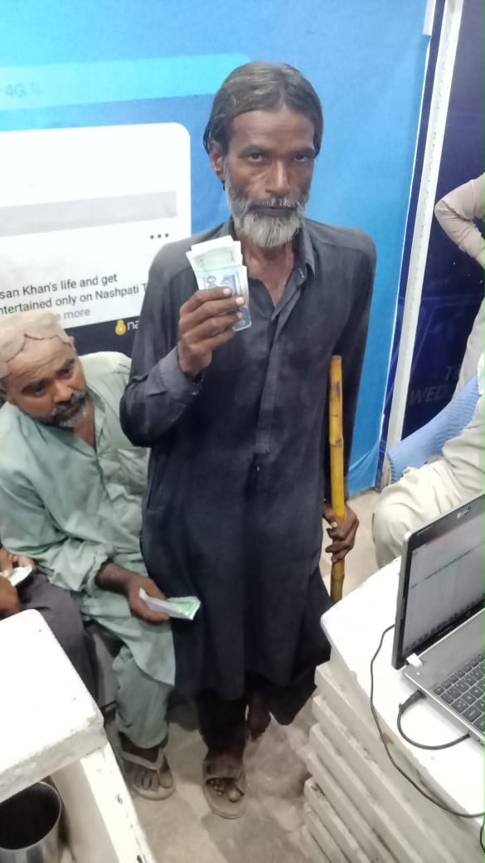
Allah Dino
CNIC Num : 5320308867663 Date Of Birth : Mob Num : 03423827926
As per me I have no source of income and I have a disability that I don’t have a Leg and SRPO Jacobabad team visited my village and considered me as per their criteria and given me the token so I could utilize the amount given by SRPO as well as I am married and I have 02 children and they are too young to work and bear the household expenses and I am really thankful to SRPO Jacobabad team to help me out in such situation.
Allah Dino
(Jacobabad Flood Affected and Beneficiary of CBT- SRPO/WFP)

